Delta Sigma Theta Sorority, Inc.
Inkster Alumnae Chapter ∙ Executive Board Meeting Minutes
Thursday, October 28, 2021

CALL TO ORDER
Meeting called to order at 6:02 PM by Soror Vivian Kirkland
Prayer by Soror Shai James-Boyd

Agenda and Minutes
- Soror L. Barclay Abrams motioned to accept the October 28th Executive Board Meeting Agenda, Seconded by Soror Shai James-Boyd, with 100% approval.
- September 23rd Executive Board Meeting minutes were approved as distributed.

COMMUNICATIONS: Soror Faith Ivey
- I. National Mail:
- II. Regional Mail:
- III. General Mail:
- IV. Committee Mail:
- V. Other Correspondences:
- A. (1) Ann Arbor Alumnae Chapter (dues transfer)
  - (2)
  - (3) Events N/A

TREASURER’S REPORT / FINANCIAL SECRETARY: Soror Tanisha Hester and Soror Joi Miller
2021 – 2022 Sorority Year Financial Recap (as of 9/30/2021)

- Ending Book Balance (all accounts)  - Total Credits (September: all accounts)  - Total Debits (September: all accounts)  - Total Difference (September: all accounts)  - Total Financial Members (as of 9/30/2021) |  | $86,260.16  $6,143.31  $9,638.64  $0.00  117

- Please check the Crimson Cabinet to download updated financial forms.
- All forms are now 100% fillable and located in the Crimson Cabinet under IAC Chair/Committee Resources. You must download the form and open as a PDF.
- Requests on old forms will be returned for resubmission using the current form.
- Chairs are required to submit a completed Event Budget Form within 30 days of the event. This is required for events that incur expenses and/or receive receipts.

ADMINISTRATION: Soror Vivian Kirkland
- Committees Elevating, Enhancing, Empowering
  - 10/2 Rituals and Ceremonies (Omega Omega Ceremony)
  - 10/2 Delta Academy (Induction)
  - 10/10 PP&D (Risk Management Training)
  - 10/13 Physical & Mental Health (Social Media Blast: “I Wear Pink Today Because…”)
  - 10/16 Economic Development (MIDS)
  - 10/17 Scholarship/Arts & Letters (Virtual College Tour: Michigan Edition)
  - 10/17 Community Service (DST IAC Highway Cleanup)
  - 10/18 Scholarship (App online)
  - 10/23 Delta Academy (Contactless Packet Pickup, “Dream Catchers”)
  - 10/24 Physical & Mental Health (Mental Overload in the Black Woman)
  - 10/24 PP&D (Committee Update)
  - All month: ICT, Publicity/Ads
- Chapter News
  - Thank you, Soror Tracy Causey-Bryant and Soror Tiffany Crayton, for sharing your respective breast cancer journeys.
  - Thank you, Soror Regina Thomas, for sharing your feelings regarding the news of our line sister having breast cancer.
  - Review and voting polls for candidates for 55th National Convention during November Sisterhood Hour
  - Sharing IAC’s social media posts
  - Chapter Logo redesign discussion
  - 2021-22 Chapter Awards: Take Notes
    - Committee of the Year
    - Dear of the Year
    - Soror of the Year
  - Chapter Bulk Order for Ritual
    - Reserve copy by Friday, October 29th
- Chapter Logo: Want to gage how many would be interested in changing the design of the chapter logo.
- Logo design discussion:
  - Who said there was something wrong with the logo?
  - No one, I just wanted to see how many where interested in a change
  - The current logo is nice and has matching label pin.
  - This logo has clean lines which is good for transferring.
  - I could go either way but would have to see several design options.
  - I appreciate that the current logo is easily referable and transferrable.
  - If we move forward with exploration I would need to see several options.

- Vote on logo design
- 24 Sorors Present
  - 9 Yes
  - 9 No
- Issue will not be taken to the chapter.

- Chapter pictures were taken at October chapter meeting. The following committees missed the picture and need to submit a photo for the website:

  - Audit, ERT, Academy, Dears, Economic Development, ICT, Physical and Mental Health
- The first virtual sorority meeting of the year will be in November. Visiting sorors need to email their name and membership number to the president prior to the sorority meeting to be sent the link. Please do not forward the link for the sorority meeting.
- Met with state Coordinator about statewide Founders Day for the possibility of IAC hosting in 2023. Bids would have to be sent in now.
- J. Moore
- We did cluster, we can do this. We have a 30-city area to accommodate what is needed. This is a phenomenal opportunity. Other chapters can be part of the committee.
  - Statewide Founders Day Vote
  - 14 Yes
  - 4 No

REGIONAL
- 10/1 Midwest Region Awards
- Congratulations to Arts and Letters for 3rd Place Small Chapter Award!!!!
- 10/4 Membership Intake Updates
- “Must have attended at least two of the last three National Conventions AND two of the last three Regional Conferences held prior to her nomination (to the Minerva Circle)”
- 2021 National Convention - Atlanta
- 2019 National Convention - New Orleans
- 2017 National Convention - Houston
- 2020 Regional Conference - Virtual
- 2018 Regional Conference - Cincinnati
- 2016 Regional Conference - Indianapolis
- Midwest Missile Submission October 31 at 11:59pm CST

NATIONAL
- 10/1 National Headquarters Virtual Tour
- 10/2 Grand Chapter Quarterly Financial Report & Financial Statements
- Reminder: 55th National Convention Early Bird Workshop
- Began 9/12 and runs until 11/12
- 10/15 Delta Red Pages Business Directory
- Registration is open until 12/17
- 10/25 National Listening Session with Goldman Sachs
- Friday, October 29 @ 8PM EST
- New initiative “One Million Black Women”
- $10B investment over 10 years
- Education, Healthcare, Financial Health, Access to Capital, Workforce and Job Creation

PROGRAM PLANNING: Soror Larissa Barclay Abrams:
- Past Events:
- Risk Management Training October 10th
- Midwest Impact Day of Service October 16th
- Committee Update Meeting October 24th
- Delta GEMS Officer Orientation October 25th

- 1st Quarter Activity Snapshot
- > 100 committee meetings
- 14 programs/events
- Master Calendar
- Programming
- -National initiatives
- Planning
- -Approval Process
- Remember: Chapter events and meetings may be virtual or face to face, no hybrid events. Virtual only youth programming until further notice.
- Development
- -Collaboration?
- -Community partners?
- -Community benefit?
- Demographic forms
- Converted to Google Form
- Link available in the Crimson Cabinet
- http://forms.gle/hDotzhoLwQFZyAkw7
- Program Evaluation Form
- Converted to Google Form and QR Code
- Link available in the Crimson Cabinet
- https://forms.gle/dbhCZkzQqRCw7z3c7

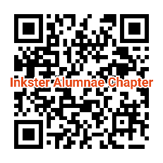
- Strategic Planning for Award Winning Programs
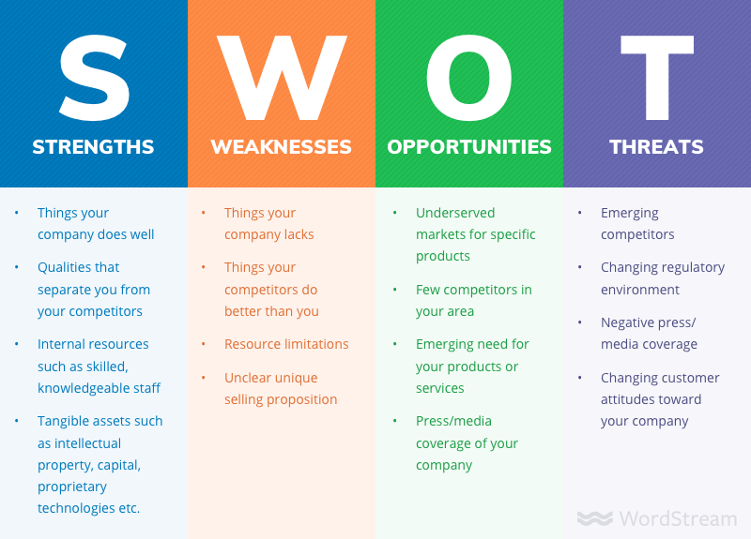

- How Do We Win awards??
- Creative programs
- Programs with community value
- Collaborative opportunities
- Record Keeping
- Photos
- Flyers
- Program summarization
- Awards Submission Template
- Converting to Google Form
- Proactive Completion
- Program summarization
- Regional Updates
- Midwest Impact Day of Service (MIDS) 2021 Saturday, October 16th
- Economic Development (Financial Wellness)
- Theme: Secure the Bag, Buy Black
- MIDS#2021
- Goal: Encourage financial wellness within the black business community
- Increase in sales amongst participating black-owned businesses
- Who? How? Impact??
- Midwest Impact Day of Service
- 7k Customz Apparel and Printing
- Black Lit Matters
- Iconic Booths
- Dazzled Divas
- Gabrielle Nicole Makeup Artistry
- Janna Kay Charcuterie Boxes and Boards
- Kays Kisses
- Marie’s Memories Bakery
- Rajaevu Clothing Company
- Tables Tents and Things
- The Wise Decsicion
- Unique Greek Boutique
- National Updates
- 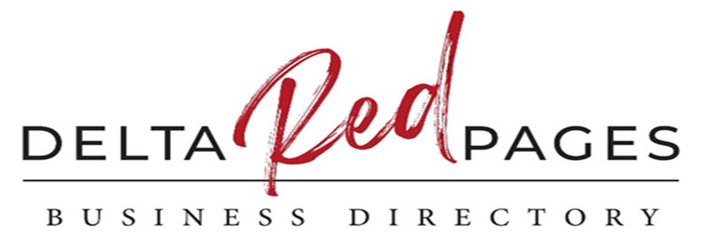
- The National PPD Committee’s Economic Development Subcommittee is releasing the 2nd volume of the Delta Red Pages.
- Interactive, online directory that allows Delta business owners to participate for a non-refundable fee.
- Enhances awareness of your Delta-owned businesses and nonprofits, allowing you the opportunity to reach sorors across the globe.
- The criteria to be listed in the Delta Red Pages are as follows:
- Participation will be subscription-based with an introductory non-refundable annual fee of $50.
- Active subscriptions will follow the Sorority’s fiscal year period from July 1st to June 30th, 2022.
- Registration will be open until December 17, 2021 at 11:59 pm EST.
- Soror business owners must be a financial member to register. Must be financial for the 2021-2022 Sorority year.
- Businesses must be actively registered in the state of operation to participate in this initiative. A state licensing document is required as proof.
- Sorors may be co-owners of businesses with a non-soror, but the soror must be the primary contact for the directory.
- Important update sorors! Due to the overwhelming interest, the Delta Red Pages registration drawing has been extended! Those who register for the Red Pages by October 31, 2021 at 11:59 pm EST will be entered to receive a $1,000 cash prize from one of our strategic partners, the dfree Global Foundation.
- To register for the Delta Red Tank Competition, log in to your member profile here: https://delta.dstonline.org/DSTMember/Events/Red_Pages/Event_Display.aspx
- WW is the Official Wellness Partner of DeltaCare!
- Holistic wellness for sorors
- WW enhances current Physical & Mental Health initiatives by give sorors access to personalized resources and tools to achieve their wellness goals.
- The Wellness Partnership Includes:
- 25% discount on all memberships through December 31, 2021
- A chance to win free tickets to Oprah's 2020 Vision Tour
- Curated wellness experiences at the 2020 regional conferences and the 2021 national convention
- Information and resources via email blasts and social content
- Scholarship donations
- Nutrition and fitness education to build healthier lifestyles
- Private digital DST Connect Group in the WW App
- Partnership with the Physical and Mental Health Subcommittee to inspire programing to encourage the wellness journey
- And more!
- Chapter events and meetings may be virtual or face to face, no hybrid events. Virtual only youth programming until further notice.
- Reminders
- Calendar Updates
- Demographic Forms
- Evaluation Forms
- Committee Update Meetings: Monthly, 4th Sunday, 8pm Next meeting – November 28th via Google Meet
- Chapter events and meetings may be virtual or face to face, no hybrid events. Virtual only youth programming until further notice.
- Questions?

MEMBERSHIP: Soror Melissa Crumbey
- PAST EVENT: N/A
- UPCOMING EVENT: IAC Holiday Party
    - Who: Calling all IAC Sorors
    - What: Painting w/a Virtual Twist, Secret Soror Gift Exchange and More
    - When: Saturday, December 11th @5 p.m. – 7 p.m.
    - Where: Virtual
    - Why: Because every moment of fellowship with our sisters is a moment to laugh, live, and love

NOVEMBER BIRTHDAYS
- Monique Williams November 1
- Adrena Crowder November 5
- Kym Maynor-Legreair November 7
- Roslyn Fluker November 10
- Vivian Flounory November 10
- Ashley Hardison November 11
- Jazmyn Bradford November 14
- Gabrielle Thomas November 25
- Rolanda Davis November 28

NOVEMBER DELTA ANNIVERSARIES
Congratulations on another year in Delta

- Sharon Brooks-Jackson 11/16/1969
- Michele Nelms 11/12/1970
- Roslyn Oliver 11/18/1978
- Vivian Kirkland 11/19/1989
- Lyn Roberts 11/09/1991
- Regina Thomas 11/19/1989
- Jenita Moore 11/23/1991
- D’Amrique Thompson-Simmons 11/22/2008

- Care and Concern
- May, of the Express 34 Line of 1991.
- The sisterhood of IAC supports and surrounds our Sorors with love, in the loss of our own IAC initiated Soror Sharon E. May, of the Express 34 Line of 1991.
- Condolences may be sent to: Benjamin Hodge III at 17228 Shervilla Place, Southfield, MI 48075
- Please keep the family, Sands, Sorors, and friends of Soror May in your prayers

- VISITING SORORS
On Behalf of the Membership of IAC, we welcome you!

DELTA ACADEMY: Soror Kennetha Thompson presented by President Vivian Kirkland
Chair: Dr. Kennetha S. Thompson
- PAST EVENTS :
    - Contactless Packet Pickup on Saturday, Oct. 23 (see attached pictures)
- UPCOMING EVENTS:
  - Self Esteem Workshop on Saturday, Nov. 6 (virtual) at 12 noon
- COMMITTEE MEETING INFORMATION:
  - Next Meeting: Wednesday, November 17, 2021 at 7pm via Google Meet

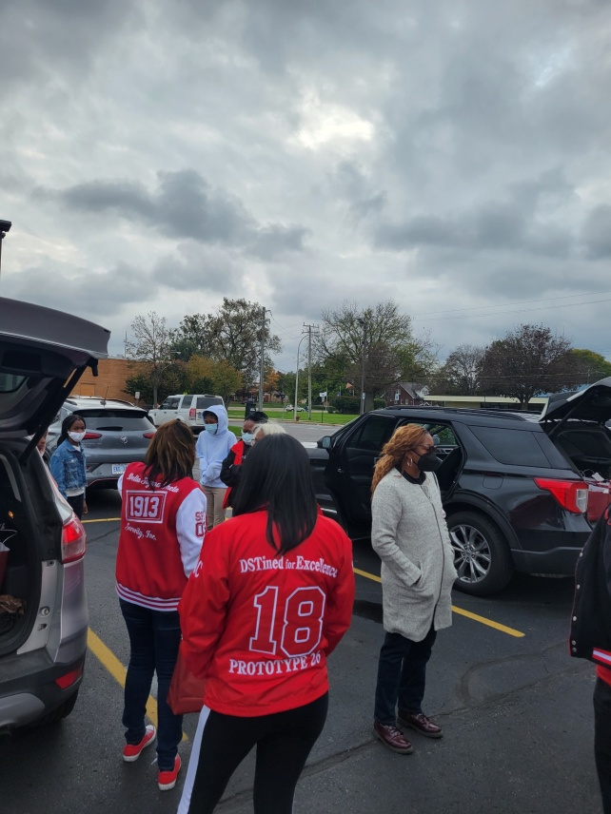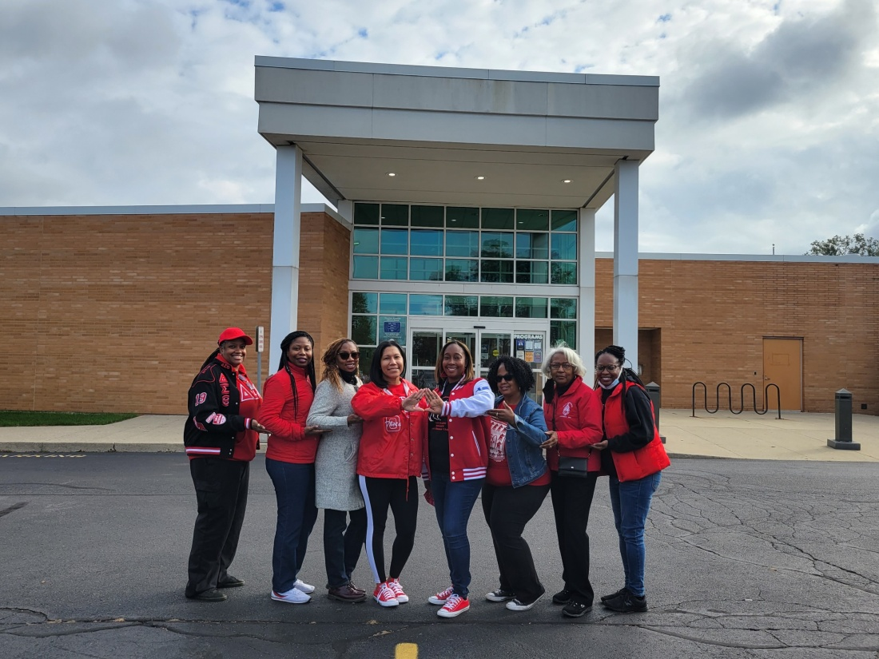
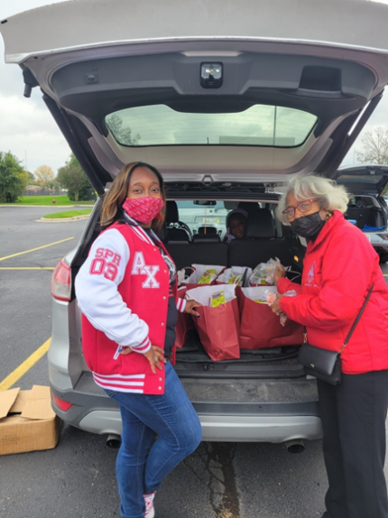

GEMS: Soror Jazmyn Bradford
- NO REPORT

SCHOLARSHIP & FUNDRAISING: Soror Courtney Townsel

- NO REPORT

- ADS & Publicity: Soror Paula Wiley

- NO REPORT

- Arts & Letters: Soror Faith Ivey

Dr. Faith Ivey: Chair
Soror Johanna Kinsey: Co-Chair
- Events: Virtual College Fair, Michigan Edition in collaboration with the Scholarship Committee. October 17, 2021.
- Upcoming Events:
- Crimson Conversations Virtual Book Club, featuring the book “When the Seatbelt Sign Goes Off” by Nichole L. Davis. Please see flier for details.
- Date: November 14, 2021 Time: 2-4pm Must Register by November 12, 2021
- Delta Red Carpet Movie v. King Richard, is released in movies on November 19, 2021. This film takes a look at the lives of tennis superstars, Venus and Serena Williams, and how they became who they are after the coaching from their father, Mr. Richard Williams. IAC will not gather for this event. Please adhere to How to do a Red Carpet for further guidelines.
- 3. IAC Community Literacy Campaign: As we enter the holiday season, please purchase new books for school aged students in grades K-12. We will collect new books to donate to Inkster local students, as well as participate in the Giving Tree campaign sponsored through the Leona Hicks Library, located in Inkster, MI.
- We would also like sorors to volunteer to take one of our collection bins to your place of employment to collect new books.
- 4. We will work collaboratively with local Inkster schools and the LH Library to help families sign-up for a library card virtually. All of these efforts will go towards our goal of donating age-appropriate innovative books for Reading Awareness Month in March of 2022.
- Next meeting: November 2, 2021, at 8:30pm via Google Meets: meet.google.com/ccd-wpko-yuf or by phone (US) 1 405-362-7668 PIN: 316 942 146
‬
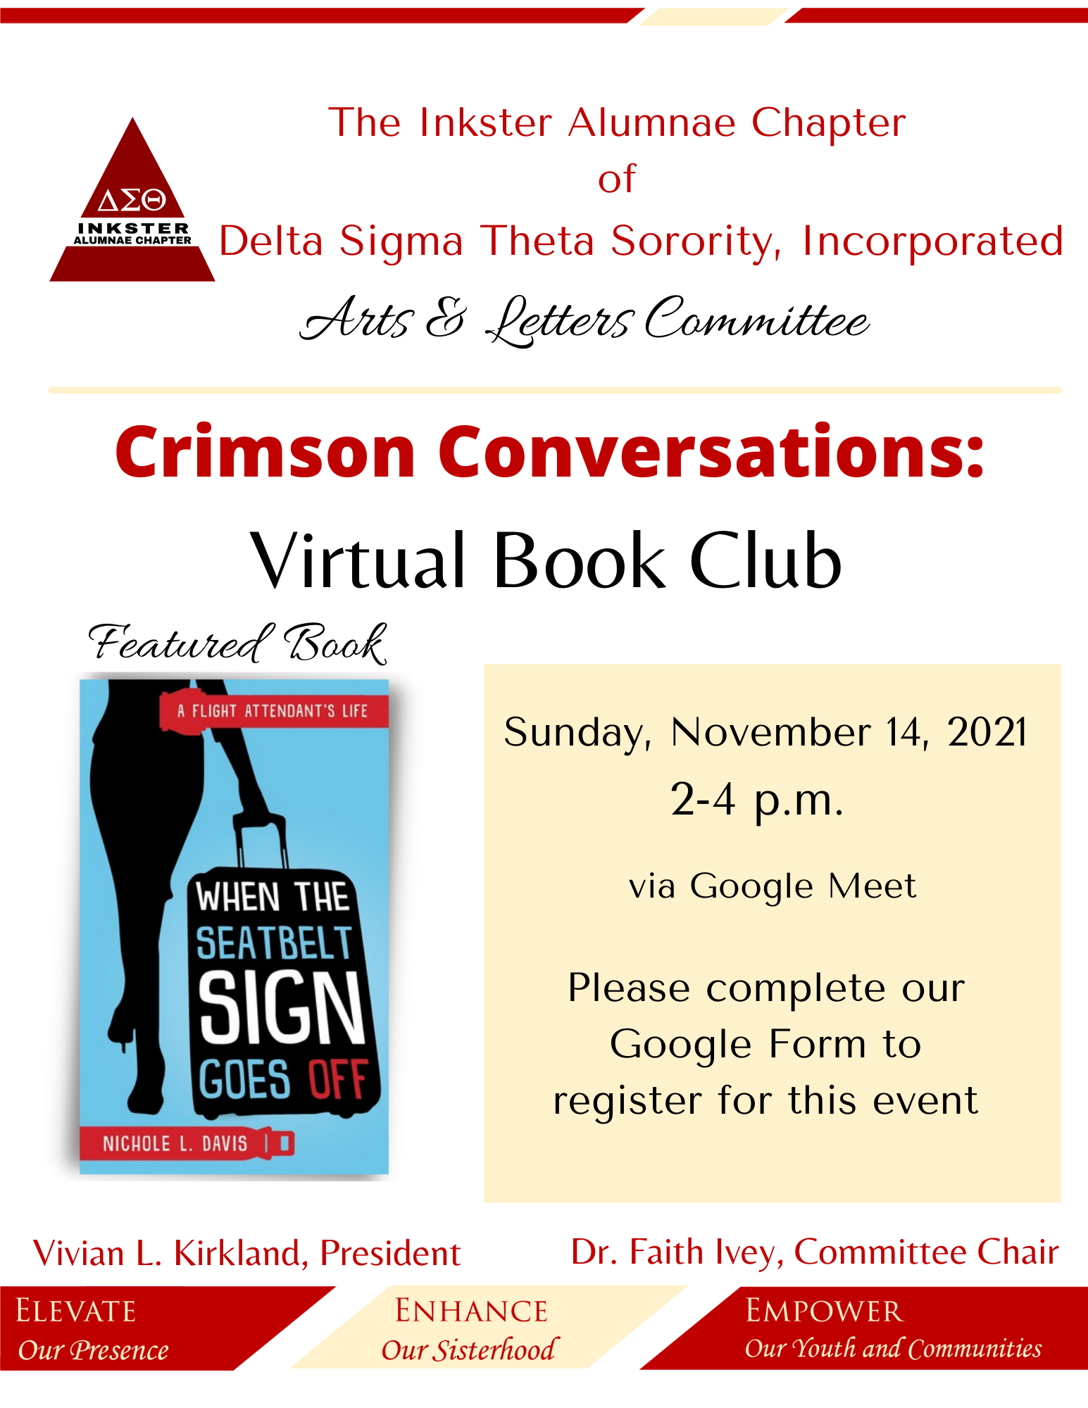

- AUDIT: Soror Adrena Crowder
- No Report

COLLEGIATE CONNECTION– Soror TaQuinda Johnson

- No Report

COMMUNITY SERVICE: Soror Gabrielle Thomas
Chair: Gabrielle Thomas CO-Chair: Breana Lewis
► PAST EVENTS:
► IAC Highway Cleanup
► Collected 13 bags of trash
► 22 Sorors in attendance
► UPCOMING EVENTS :
► Thanksgiving Basket Donation
► THURSDAY, NOVEMBER 18, 2021
► COMMITTEE MEETING INFORMATION:
► Monthly, 1st Wednesday, 8pm
► Via Google Meet (US) +1 419-812-2543
► PIN: 211 387 090 #
Community Service Committee
Thank you!!!#

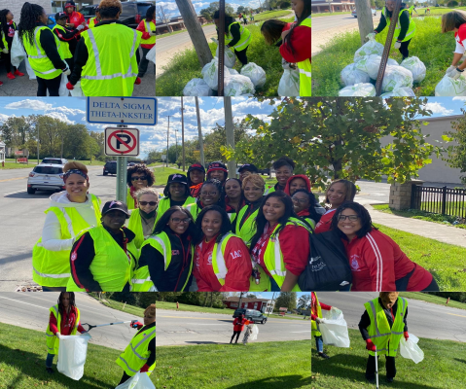

DELTA DEARS: Soror R. Lorraine Hurst Presented by President Vivian Kirkland

- PAST EVENTS:
- Meeting October 10,2021
- Dear Captains: set up to allow closer contact with Dears and availability
to address concerns and direct line for assistance.
Delta Buddies: set up to foster Sisterhood, A Dear is paired with Soror to develop
a new relationship.
- UPCOMING EVENTS:
- Next Meeting of all Delta Dears November 14, 2021
- COMMITTEE MEETING INFORMATION:
  - Monthly, 2nd Sunday, 7:00 pm
  - On Google Meet
  - Please email Delta Dears if interested in being on Committee

ECONOMIC DEVELOPMENT: Soror LaTanya Burge

- NO REPORT

EMERGENCY RESPOSE TEAM: Soror Lisa Harrington Shorter

- PAST EVENTS : N/A
- UPCOMING EVENTS :
- No upcoming events within 30 days.
- Just want to remind and encourage Sorors to carry and update your RED Envelops as necessary. If you did not complete one last sorority year, please consider doing so this year.
  - If you are going to National Convention, please carry it with you. A fillable form will be in the Crimson Cabinet.
  - For in-person meetings and activities, National is encouraging the use of a COVID-19 questionnaire/screening. This can be conducted electronically. There is also a Meeting Assessment for available if you need to get feedback from the chapter on Soror’s concerns for in-person activities.
- For Sorors that experience a hardship, the Delta Research and Educational Foundation (DREF) has developed a new application form. The link for the new submission form will be available in the Crimson Cabinet.
- If the chapter or individual Sorors want to support Relief efforts, you may do so through the following ways: Tax deductible on-line donations at DREF Mobile Cause site [https://app.mobilecause.com/form/ObylTw?vid=luyqi] OR mail contributions to: The Delta Research and Educational Foundation 1702 New Hampshire Avenue, NW Washington, DC 20009.
- Continue to follow Covid-19 protocols.

HERITAGE AND ARCHIVES: Soror Shareia Carter
Heritage & Archives 2021-2023
Inkster Alumnae Chapter
- PAST EVENTS:
- No past events
- UPCOMING EVENTS :
- The links are ready to receive submissions!!!! Feel free to submit multiple forms!
- To submit your photos and description to the Inkster V.A.U.L.T., please use this link:
- https://forms.gle/CqUZUg825eN7hVFa7
- To submit your Dear “Inkster Alumnae Chapter” Letter, please use this link:
- https://forms.gle/E6HxExJWkmcDaJxh8
- Be creative
- We all have a story to share!
- COMMITTEE MEETING INFORMATION:
- The Heritage and Archives Committee will meet the first Monday of every month from 7:30-8:30pm. Please find the Google Meet information below:
- meet.google.com/coj-hsqi-xed

INFORMATION, COMMUICATION & TECHNOLOGY: Soror Ashley Hardison

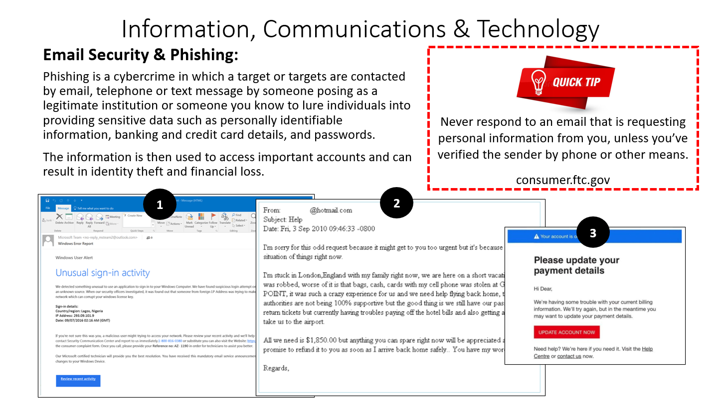

- Social Media Insights
- September 27- October 24
- Facebook
- Reach: 3.5 K
- # of Post: 20
- People: 3, 389
- Best Times: 11 am- 4 pm
- Best Days: Sunday, Tuesday, Wednesday
- # of Followers 3,627
- # of Engagements: 880
- Rate of Engagement 291%
- New Followers: 9 People
- Instagram
- Reach: 1, 066
- # of Post: 15
- People: 1,682
- Best Times: 6 am- 6 pm
- Best Days: Sunday- Saturday
- # of Followers 1,682
- # of Engagements 170
- Rate of Engagement 86.8%

- Facebook Top Post
- 10/13 Midwest Impact Day
- -726 People Reached
- -144 Engagements
- 10/10 Virtual College Tour
- -1.8 K People Reached
- -137 Engagements
- 10/11 WOW! Am.. I. Stuffed
- -710 People Reached
- -130 Engagements
- Instagram Top Post
- 10/11 WOW! Am.. I. Stuffed
- -104 Likes
- 10/13 Midwest Impact Day (Video)
  - 39 Views
- 10/5 National Headquarters Breast Cancer Awareness Post
- -24 Likes

- Newsletter Submissions

- Committee Newsletter submissions are due no later than the 25th of each month.
- Join us

- Committee Meeting Every First Sunday @ 8 PM

- Google Meet joining info
- Video call link: https://meet.google.com/feg-mokh-edx

- Dial: (US) +1 470-228-0026‬ PIN: 714 351 266‬#‬‬

INTERNATIONAL AWARENESS & INVOLVMENT: Chair Soror Patty Hines

- PAST EVENTS:
- N/A

- UPCOMING EVENTS:
- Listed is the link for the shoebox Christmas gifts.
- https://build-a-shoebox.samaritanspurse.org/view/c60de352-0eee-4640-a362-2ad5dadc02d8
- Boxes can be purchased from 10/22/21 until 11/15/21

- World Aids Day is December 1st will pass out ribbons from 3:00 to 5:00 after the meeting.

- COMMITTEE MEETING INFORMATION:
- Committee meeting call in number:
- 1-712-832-7000

PHYSICAL MENTAL & HEALTH: Soror Kamisha Stevens
Chair: Kamisha Stevens

- PAST EVENTS: October 24th WOW…Am…I…Stuffed! (Public Event)
- UPCOMING EVENTS : N/A

- COMMITTEE MEETING INFORMATION:
  - Monthly, 1st Monday 7:00pm
  - Via Google Meet Calendar Invite
Or dial
  - 929-299-3332
  - Pin: 337 693 452#
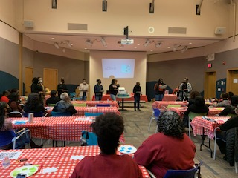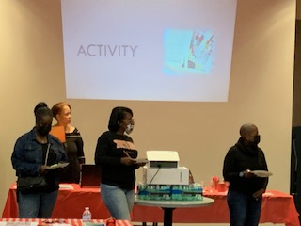

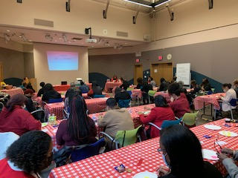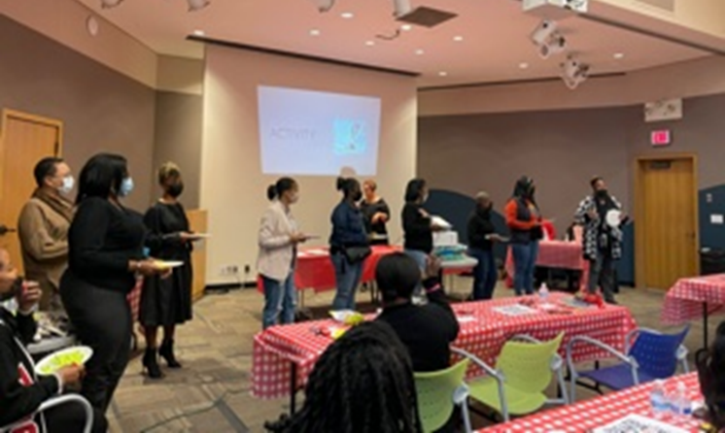
POLICY & PROCEDURES: Soror Carolyn Kimbrough

- NO REPORT

SOCIAL ACTION: Soror Karen Braxton
Chair: Soror Karen Braxton
Co-chair: Soror Donna Wilson
- PAST EVENTS
  - 10/26/2021 – Redistricting Collaboration (virtual)
    - DAC, MAC, PAC, and SAC
    - How to draw maps and what’s next in the redistricting process
- FUTURE EVENTS
  - 11/10/2021 – What’s Hair Got to Do With It?: An Informational Session to Highlight the Importance and Impact of the CROWN Act (virtual)

- COMMITTEE MEETING INFORMATION:
  - Monthly, 2nd Wednesday @ 8 p.m.
  - Google Meet
  - Email: socialaction@inksterdeltas.org

- NPHC: Soror Laurecia Smith-Witherspoon
- NO REPORT

- NOMINATING: Soror Jenita Moore

- GROW WITH GOOGLE: Soror Rhoda Pitts
- PAST EVENTS:
- Recently appointed as Chair Rhoda Pitts and Co-Chair Samantha Hampton
- UPCOMING EVENTS:
- Chair and Co-Chair will sign up for Grow with Google training October 9, 2021
- COMMITTEE MEETING INFORMATION:
- Monthly, 2nd Tuesday, 8pm

- NO REPORT
UNFINISHED BUSINESS:

- Collegiate Connection: in collaboration with Delta Beta on 11/15- Sexual Assault training beginning at 7:13 PM
  - on 12/2 having Showering Sorors with love event.
  - Would like to give vintage paraphernalia with a message.
  - There are 26 Sorors on campus.
  - We meet on the 2nd Sunday on Google Meet.
- Ads and Publicity
  - Please make sure ad requests are done 30 days before ad goes public, not 30 days before the event.
- Delta Gems
  - We would like to do care packages of black women essentials for Gems.
- Recording Secretary Grace
  - Remember that committees that did not submit a report should report out during announcements.

NEW BUSINESS:
- None

Announcements:
- The financial secretary and her sister are graduating with their second master’s degree!! (Sorors Joi Miller and Toi Flynn)

Adjournment

Motion to adjourn meeting, Soror K. Braxton seconded by Soror K. Stevens. Motion carried unanimously. Meeting adjourned at 7:51 PM.

Minutes respectfully submitted,
Soror Leslie V. Grace

