Delta Sigma Theta Sorority, Inc.
Inkster Alumnae Chapter ∙ General Body Meeting Minutes
Saturday, September 10, 2022

CALL TO ORDER
Meeting called to order at 11: 22 AM by Soror Vivian Kirkland
Quorum present at 11:22 AM
Location:
300 Henry Ruff Rd.
Westland, MI

Agenda and Minutes
- Adoption of Agenda for September 8, 2022
    - Moved by Soror Carolyn Kimbrough
    - Seconded by Soror Phyllis Martin
    - Vote by consensus- Approved 100%

- Minutes of June11, 2022 were approved as distributed

MEMBERSHIP INTAKE DISCUSSION AND VOTE
Audio of Membership intake video played.
Discussion:
Soror D’Angela Pitts, Nominating Member
Not in favor, Qualifications for the M. Circle have changed, including attending the last 2 conferences. 2 conventions and being a committee member for the last 2 years. ICT chair must also now be a member.
A yes vote would mean taking nominations from the floor today for members of the M. Circle.

COMMUNICATIONS: Soror Toi Flynn
CORRESPONDING SECRETARYSEPTEMBER REPORT

- National Mail: N/A
- Regional Mail: N/A
- General Mail: (21) pieces of mail collected
- Email: (48) received (27) sent
- Other Correspondences:
(1) Dues payment
(21) Round-Up payments
(1) Round-Up vendor payment
(1) Inkster post office correspondence
(1) Chase correspondence
(16) checks
(1) Money Gram
- Committee Mail: N/
- Budget/Finance- All Receipts Submitted ✔ Date 09/06/22

TREASURER’S REPORT / FINANCIAL SECRETARY: Soror Tanisha
2022 – 2023 Sorority Year Financial Rec1ap (as of 8/31/2022)
Total CY Financial Members (as of 9/8/2022) 117
Treasurer: Tanisha Hester; Assistant Treasurer: Kmbali Carey
Financial Secretary: Joi Miller; Assistant Financial Secretary Monik Thomas

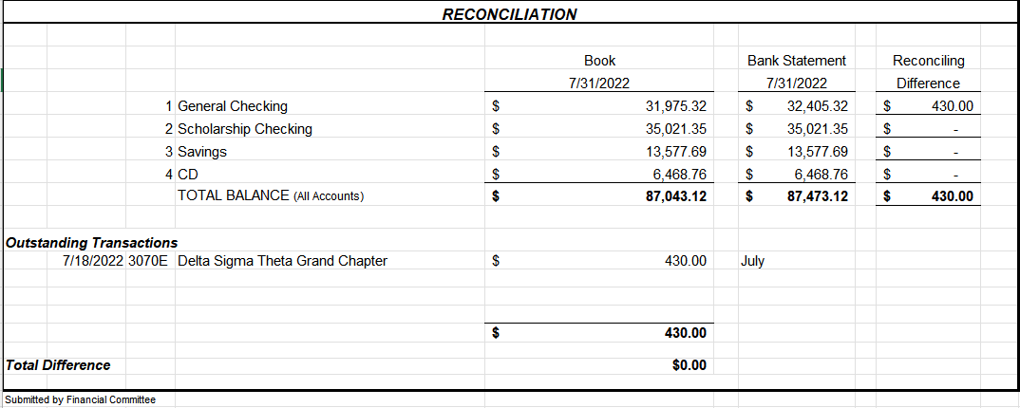

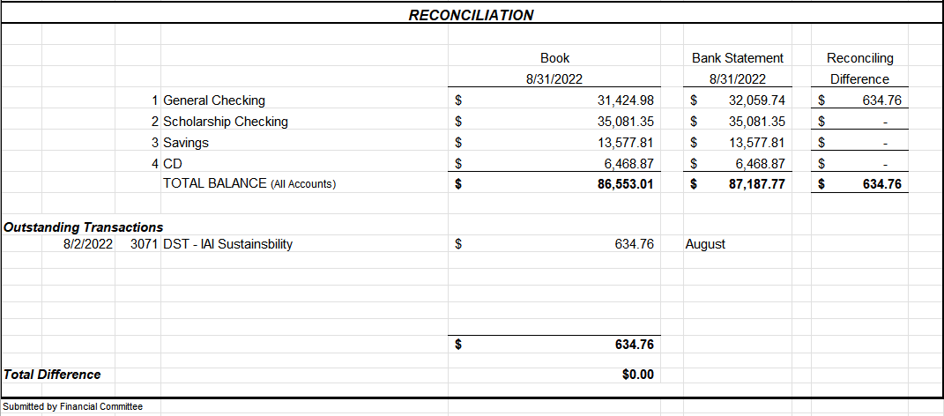

Proposed Budget Changes

Discission:
Soror S. Harris/Hester- The Property and Housing need for $600 is for the cleaning of garments and the upkeep of materials.

Soror Ivey/Hester- Why were funds not allocated to Arts and Letters. Hester- They did not submit a budget form.

Hester- $43,000 is what was submitted for requests, we have $42,000 presenting a shortfall. Funds will be reallocated as they come in.

Soror T. Hester, Chair moved to approve proposed 2022-23 budget changes 2nd by Soror R. Lorraine Hurst

Soror K. Braxton- Social Action did not get fully funded
- The Expungement Fair check will show that Social Action has more money in their budget line items than requested because this check was from 21-22 sorority year.

Soror Wilson Johnson- Propose to adjust the budget to give Arts and Letters $400 to start.
Soror Hester- I move that we make budget changes with $500 going to Arts and Letters, $2,00 to GEMS, $800 to Academy, $1166.15 to Scholarship Events and $600 to Housing and Properties.
2nd by S. Carter
Vote by Consensus
100% Carried

ADMINISTRATION: Soror Vivian Kirkland
President: Vivian L. Kirkland

Past Events: August 2022
- 50th Midwest Regional Conference: We Elevated Our Presence
  - 39 IAC Sorors attended in person
  - 8 IAC Sorors attended virtually
  - National Finance Chair
  - National Social Action Commissioner
  - Michigan State Coordinator
  - Michigan State Secretary
  - Credentials Committee Member
  - Rules Committee Chair
  - Rules Committee Member
  - Elections Committee Member
  - Page (2)
  - Shadow (2)
  - Newly Elected Member of the 2024 Regional Nominating Committee
  - 1st Place for Arts & Letters
- 50th Midwest Regional Conference: We Enhanced Our Sisterhood
  - Pictures, pictures, pictures!
- 50th Midwest Regional Conference: We Empowered Our Selves
  - 1st Place Award says we can do it again and then some!
- Copy of the MWRC Souvenir Journal
- 1st Place Award
- Past Events: September 2022
- 2022-23 Chapter Compliance received 9/1/22!
  - Welcome to new members of IAC!
- Welcome to new members of the Executive Board
- Soror Monik Thomas, Asst. Financial Secretary
- Soror Rhonda Fowler, Chair, International Awareness and Involvement
- Soror Charis Bly, Chair, Arts and Letters
- National Convention Chartered Bus

- Chapter Meeting Location Discussion

- Soror Lisa Harrington-Shorter ERT Chair

ERT would like to go virtual to protect from cold, flu, and Covid doing what keeps us most safe.

- Soror C. Kimbrough
  - Could we do hybrid?
    - Not an option at this time
- Soror S. Harris
  - As DEAR some don’t live close. Drive in winter can be treacherous, but I would like programs in person.

President Vivian Kirkland
We will have In-Person meetings the months of October, November and April- June with virtual meetings December through March.
Moved by S. Carter
2nd by K. Carey
Vote by Consensus
100% Carried

- Next Friday we encourage Sorors to go see “Woman King” with another Soror

- A Google form will be sent out to determine Soror interest in obtaining a charter bus to attend the National Convention in Indianapolis next year.

PROGRAM PLANNING AND DEVELOPMENT: Soror Larissa Barclay Abrams presented by Soror Leslie Grace
2021-2022 Successes
Use of Google Forms for:
Calendar planning
- Collecting Demographic Data
- Collecting Program Evaluation Data
- Relevant programming
- Timely documentation
- Demographic forms
- Evaluation forms
Award submissions
2022 – 2023 Goals
- Create and implement programs that more closely align with
- Grand Chapter Initiatives. We received updated information at the regional conference. Will share when finalized version received.
- Master Calendar - Realistic calendar planning. More does not mean quality.
- Timely demographic forms - 100% compliance. Due within 10 of your completed event or program
- Risk Management - 100% compliance
- Award submission – submit for all

Sisterly Reminders
- Please provide updated information:
- Who are your committee members and what are your committee meeting
- dates and meeting login information
- Calendar Planning – Limit events scheduled on the same day to 2. If you are unsure, please reach out to me
- Calendar Submission – The calendar is incomplete. Please upload your calendar updates via the link or QR code in the Crimson cabinet asap
- Program Evaluations – Please make sure your program participants complete your program evaluation form via QR code or link
- Demographic Forms– Please submit all demographic information within 10 days of completing your program via QR code or link in Crimson Cabinet
Save the Dates
- Calendar Updates - Due September 1st. None received
- Committee Update Meetings - Sunday evenings before EBoard
- Risk Management Trainings – Tentatively scheduled for
- September 18th and October 23rd (Sorors), September 25th (Delta Academy & Delta G.E.M.S. participants, parents, and volunteers)
- October 15th – Regional Impact Day of Service

MEMBERSHIP: Soror Melissa Crumbey presented by Soror Leslie Grace
Past Event: None
Upcoming Event:
- Round Up 2022
- ~100 registered Sorors
- 5 Vendors

- September Birthdays and September Anniversaries Presented

- Care and Concern
- Soror Roslyn Fluker in the loss of her mother, Dr. Deletha Motley
- Soror Kristin Reed in the loss of her brother, Mr. Terrance Baynes

DELTA ACADEMY: Soror Kennetha Thompson
- NO REPORT
GEMS: Soror Jazmyn Bradford presented by Soror Karisha Springer Floyd
- Chair: Jazmyn Bradford Co-Chair: Karisha Floyd

- Past Events: None
- Upcoming Events: General Body Meeting (Goal Setting) on Thursday, September 15, 2022 from 6pm to 8pm at the Caroline Kennedy Library of Dearborn Heights
- Budget/Finance- All Receipts Submitted __Y____ Date __3/1____
- Demographic Form Submitted ___N/A___ Date ___N/A___
- Participant Evaluation Form Submitted __N/A____ Date __N/A____
Question:
Floyd: Is there still time to request more money for the budget? Will speak offline to Treasurer (President).

SCHOLARSHIP & FUNDRAISING: Soror Courtney Townsel presented by Soror D’Angela Pitts
Chair: Dr. Courtney Townsel Co-Chair: Charmese Armstrong

- Past Events: none
- Upcoming Events:
- Virtual College Tour: “HBCU Edition”
- 10/08/2022
- 1:00 – 3:00 pm

ADS & Publicity: Soror Paula Wiley
- NO REPORT

Arts & Letters: Soror Charis Bly,
- NO REPORT

AUDIT: Soror Adrena Crowder
- NO REPORT

COLLEGIATE CONNECTION– Soror TaQuinda Johnson
- NO REPORT
.

COMMUNITY SERVICE: Soror Gabrielle Thomas
- NO REPORT

DELTA DEARS: Soror R. Lorraine Hurst
- NO REPORT

ECONOMIC DEVELOPMENT: Open
- NO REPORT

EMERGENCY RESPOSE TEAM: Soror Lisa Harrington Shorter

Committee Chair: Soror Lisa Shorter Co-Chair: Soror Leslie Grace

- Past Events: None
- Upcoming Events: September is National Disaster Preparedness Month
- The National Delta E.R.T. Campaign continues:
- E - Emergency Plan for your family
- R- RED Envelope should be in your purse, car, and on your person during community service events
- T- Talk and tell a Soror the time and location of the community event you are attending.
COVID Care - The three W’s
  - Wear your mask - Wash your hands - Walk and stand 6 ft away from others
  - Budget/Finance- All Receipts Submitted __N/A____ Date ______
  - Demographic Form Submitted _N/A_____ Date ______
  - Participant Evaluation Form Submitted _N/A_____ Date ______

HERITAGE AND ARCHIVES: Soror Shareia Carter
- NO REPORT

HOUSING AND PROPERTIES: Soror LaTanya Beanum
  - NO REPORT

INFORMATION, COMMUICATION & TECHNOLOGY: Soror Ashley Hardison
  - NO REPORT

INTERNATIONAL AWARENESS & INVOLVMENT: Chair Soror Rhonda Fowler
- NO REPORT

.

NPHC : Chair Soror Laurecia Smith-Witherspoon
- NO REPORT

PHYSICAL MENTAL & HEALTH: Soror Kamisha Stevens presented by Soror Krystal Martin
Chair: Kamisha Stevens Co-Chair: Krystal Martin
- Past Events: on August 20th we joined our Alumnae Chapters for the 34th Annual UNCF Walk For Education at Belle Isle
- Upcoming Events: N/A

POLICY & PROCEDURES: Soror Paula Wiley

- NO REPORT

SOCIAL ACTION: Soror Karen Braxton
PAST EVENTS:
- None within past 30 days
- UPCOMING EVENTS
- Plymouth/Canton School Board Candidate Forum
- September 19 @ 6 p.m.
- Canton Township Board Room

  - Budget/Finance- All Receipts Submitted ___X___ Date 06/27/2022
  - Demographic Form Submitted __X____ Date 06/27/2022
  - Participant Evaluation Form Submitted __X____ Date 06/27/2022

NOMINATING: Soror Jenita Moore

- NO REPORT

UNFINISHED BUSINESS:

- Membership Intake Vote Results
  - Vote By Secret Tally
  - Total 58 Ballots
  - For 3
  - Against 55
  - Abstain 0
  - Ineligible 0
  - Result Motion does not carry

NEW BUSINESS:
- None

ANNOUNCEMENTS:
- Soror Jessika Kennedy, NPHC Rep
  - NPHC had a successful Greek weekend

ADJOURNMENT:

Motion to adjourn meeting, Soror R. Lorraine Hurst, seconded by Soror D’Angela Pitts. Motion carried unanimously by consensus vote. Meeting adjourned 1:03 PM.

Minutes respectfully submitted,
Soror Leslie V. Grace

Received by Inkster Alumnae Chapter President, Vivian Kirkland_____________________________

