Delta Sigma Theta Sorority, Inc.
Inkster Alumnae Chapter ∙ Executive Board Meeting Minutes
Thursday, September 8, 2022

CALL TO ORDER
Meeting called to order at 6:00 PM by Soror Vivian Kirkland
Quorum present at 6:00 PM
Prayer- Soror Shai James-Boyd
Location: Google Meet https://meet.google.com/rdm-svwm-vnr

Agenda and Minutes
- Adoption of Agenda for September 8, 2022
    - Moved by Soror Jessika Kennedy
    - Seconded by Soror Ingrid Wilson Johnson
    - Vote by consensus- Approved 100%

- Minutes for May 266, 2022 approved as distributed

COMMUNICATIONS: Soror Toi Flynn
CORRESPONDING SECRETARYSEPTEMBER REPORT

- National Mail: N/A
- Regional Mail: N/A
- General Mail: (21) pieces of mail collected
- Email: (48) received (27) sent
- Other Correspondences:
(1) Dues payment
(21) Round-Up payments
(1) Round-Up vendor payment
(1)Inkster post office correspondence
(1) Chase correspondence
(16) checks
(1) Money Gram
- Committee Mail: N/
- Budget/Finance- All Receipts Submitted ✔ Date 09/06/22

TREASURER’S REPORT / FINANCIAL SECRETARY: Soror Tanisha
2022 – 2023 Sorority Year Financial Recap (as of 8/31/2022)
Total CY Financial Members (as of 9/8/2022) 117
Treasurer: Tanisha Hester; Assistant Treasurer: Kmbali Carey
Financial Secretary: Joi Miller; Assistant Financial Secretary Monik Thomas

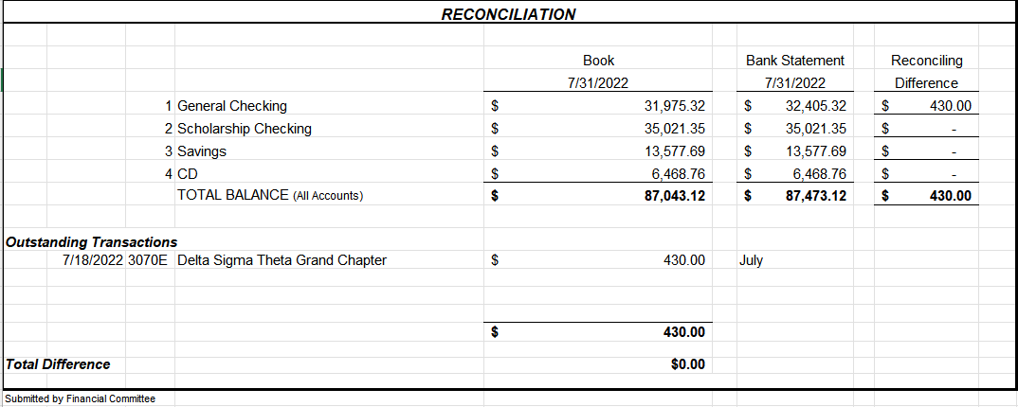

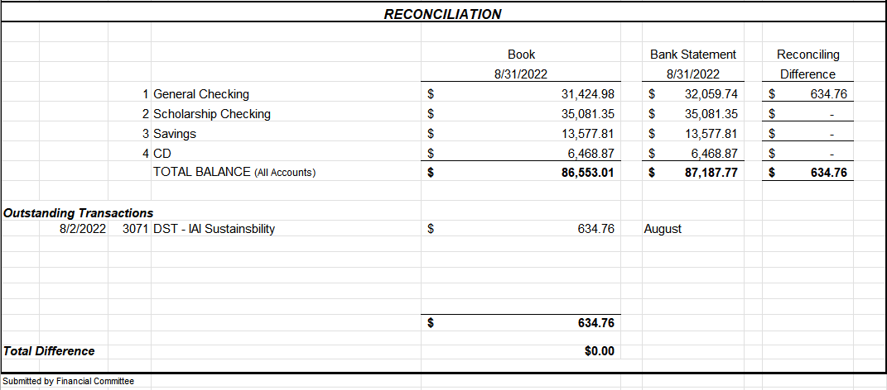
Updated 2022-23 Budget Presented
Questions and Discussion:
Wilson-Johnson-Why is scholarship requesting money from the general fund?
-This will be for events and this line item will now be called “Scholarship Events”
Treasurer there are recommended budget changes presented- though not all committees will not be getting all the funds requested because there is an overall shortfall
J. Moore- Items on the spreadsheet need to be presented on the slide as proposed budget changes to be voted on by the chapter.

The budget changes are as follow:

Soror T. Hester, Chair moved to approve proposed 2022-23 budget changes 2nd by Soror Ingrid Wilson Johnson
Vote by Consensus
100% Carried

ADMINISTRATION: Soror Vivian Kirkland
Past Events: August 2022
- 50th Midwest Regional Conference: We Elevated Our Presence
  - 39 IAC Sorors attended in person
  - 8 IAC Sorors attended virtually
  - National Finance Chair
  - National Social Action Commissioner
  - Michigan State Coordinator
  - Michigan State Secretary
  - Credentials Committee Member
  - Rules Committee Chair
  - Rules Committee Member
  - Elections Committee Member
  - Page (2)
  - Newly Elected Member of the 2024 Regional Nominating Committee
  - 1st Place for Arts & Letters
- 50th Midwest Regional Conference: We Enhanced Our Sisterhood
- Pictures, pictures, pictures!
- 50th Midwest Regional Conference: We Empowered Our Selves

- 1st Place Award says we can do it again and then some!

- Copy of the MWRC Souvenir Journal

Past Events: September 2022

- 2022-23 Chapter Compliance received 9/1/22!

MIT Discussion

J. Moore- Level 3 MIT Trainer, Don’t think we are ready as the chapter has had difficulty finding committee chairs and people to do the work. Additionally, there are several new changes that would disqualify many members from participating and would cause a lager commitment for others
The Technology chair must now be a member of the of circle
Circle members must have attended two of the last 3 conferences and conventions
Chapter programming must continue throughout the process

D. Pitts- Agrees with Soror Moore
Additionally, Sorors must be a committee member for two years, meaning that those that just transferred in could not be on the circle.

President- Please be sure to state your point of view to the full chapter prior to the vote.

PROGRAM PLANNING AND DEVELOPMENT: Soror Larissa Barclay Abrams presented by Soror Vivian Kirkland
2021-2022 Successes
Use of Google Forms for:
Calendar planning
- Collecting Demographic Data
- Collecting Program Evaluation Data
- Relevant programming
- Timely documentation
- Demographic forms
- Evaluation forms
Award submissions
2022 – 2023 Goals
- Create and implement programs that more closely align with
- Grand Chapter Initiatives. We received updated information at the regional conference. Will share when finalized version received.
- Master Calendar - Realistic calendar planning. More does not mean quality.
- Timely demographic forms - 100% compliance. Due within 10 of your completed event or program
- Risk Management - 100% compliance
- Award submission – submit for all

Sisterly Reminders
- Please provide updated information:
- Who are your committee members and what are your committee meeting
- dates and meeting login information
- Calendar Planning – Limit events scheduled on the same day to 2. If you are unsure, please reach out to me
- Calendar Submission – The calendar is incomplete. Please upload your calendar updates via the link or QR code in the Crimson cabinet asap
- Program Evaluations – Please make sure your program participants complete your program evaluation form via QR code or link
- Demographic Forms– Please submit all demographic information within 10 days of completing your program via QR code or link in Crimson Cabinet
Save the Dates
- Calendar Updates - Due September 1st. None received
- Committee Update Meetings - Sunday evenings before EBoard
- Risk Management Trainings – Tentatively scheduled for
- September 18th and October 23rd (Sorors), September 25th (Delta Academy & Delta G.E.M.S. participants, parents, and volunteers)
- October 15th – Regional Impact Day of Service

MEMBERSHIP: Soror Melissa Crumbey presented by Soror Vivian Kirkland
Past Event: None
Upcoming Event:
- Round Up 2022
- ~100 registered Sorors
- 5 Vendors

- September Birthdays and September Anniversaries Presented

- Care and Concern
- Soror Roslyn Fluker in the loss of her mother, Dr. Deletha Motley
- Soror Kristin Reed in the loss of her brother, Mr. Terrance Baynes

DELTA ACADEMY: Soror Kennetha Thompson
- NO REPORT
GEMS: Soror Jazmyn Bradford presented by Soror Karisha Springer Floyd
- Chair: Jazmyn Bradford Co-Chair: Karisha Floyd

- Past Events: None
- Upcoming Events: General Body Meeting (Goal Setting) on Thursday, September 15, 2022 from 6pm to 8pm at the Caroline Kennedy Library of Dearborn Heights
- Budget/Finance- All Receipts Submitted __Y____ Date __3/1____
- Demographic Form Submitted ___N/A___ Date ___N/A___
- Participant Evaluation Form Submitted __N/A____ Date __N/A____
Question:
Floyd: Is there still time to request more money for the budget? Will speak offline to Treasurer (President).

SCHOLARSHIP & FUNDRAISING: Soror Courtney Townsel presented by Soror D’Angela Pitts
Chair: Dr. Courtney Townsel Co-Chair: Charmese Armstrong

- Past Events: none
- Upcoming Events:
- Virtual College Tour: “HBCU Edition”
- 10/08/2022
- 1:00 – 3:00 pm

ADS & Publicity: Soror Paula Wiley
- NO REPORT

Arts & Letters: Soror Charis Bly,
- NO REPORT

AUDIT: Soror Adrena Crowder
- NO REPORT

COLLEGIATE CONNECTION– Soror TaQuinda Johnson
- NO REPORT
.

COMMUNITY SERVICE: Soror Gabrielle Thomas
- NO REPORT

DELTA DEARS: Soror R. Lorraine Hurst
- NO REPORT

ECONOMIC DEVELOPMENT: Open
- NO REPORT

EMERGENCY RESPOSE TEAM: Soror Lisa Harrington Shorter

Committee Chair: Soror Lisa Shorter Co-Chair: Soror Leslie Grace

- Past Events: None
- Upcoming Events: September is National Disaster Preparedness Month
- The National Delta E.R.T. Campaign continues:
- E - Emergency Plan for your family
- R- RED Envelope should be in your purse, car, and on your person during community service events
- T- Talk and tell a Soror the time and location of the community event you are attending.
COVID Care - The three W’s
  - Wear your mask - Wash your hands - Walk and stand 6 ft away from others
  - Budget/Finance- All Receipts Submitted __N/A____ Date ______
  - Demographic Form Submitted _N/A_____ Date ______
  - Participant Evaluation Form Submitted _N/A_____ Date ______

HERITAGE AND ARCHIVES: Soror Shareia Carter
- NO REPORT

HOUSING AND PROPERTIES: Soror LaTanya Beanum
  - NO REPORT

INFORMATION, COMMUICATION & TECHNOLOGY: Soror Ashley Hardison
  - NO REPORT

INTERNATIONAL AWARENESS & INVOLVMENT: Chair Soror Rhonda Fowler
- NO REPORT

.

NPHC : Chair Soror Laurecia Smith-Witherspoon
- NO REPORT

PHYSICAL MENTAL & HEALTH: Soror Kamisha Stevens
Chair: Kamisha Stevens Co-Chair: Krystal Martin
- Past Events: on August 20th we joined our Alumnae Chapters for the 34th Annual UNCF Walk For Education at Belle Isle
- Upcoming Events: N/A

POLICY & PROCEDURES: Soror Paula Wiley

- NO REPORT

SOCIAL ACTION: Soror Karen Braxton presented by Soror Jenita Moore
PAST EVENTS:
- None within past 30 days
- UPCOMING EVENTS
- Plymouth/Canton School Board Candidate Forum
- September 19 @ 6 p.m.
- Canton Township Board Room

  - Budget/Finance- All Receipts Submitted ___X___ Date 06/27/2022
  - Demographic Form Submitted __X____ Date 06/27/2022
  - Participant Evaluation Form Submitted __X____ Date 06/27/2022

NOMINATING: Soror Jenita Moore
Chair: Jenita Moore
Members: LaTanya Beanum
D’Angela Pitts

- Past Events: N/A
- Upcoming Events: Minerva Circle Nominating Presentation if chapter votes if the affirmative. It is the responsibility of the Nominating Committee to conduct nomination of the Minerva Circle.
- The chapter president/presiding officer calls for the nominations from the floor.
- The floor will not be open for nominations on the day of the election of the Minerva Circle. A member can be nominated for more than one (1) position on the Minerva Circle.
- Upon election, the Minerva Circle is a special committee for the purpose of implementing the Membership Intake Process. At the conclusion of the intake process, the committee is dissolved

UNFINISHED BUSINESS:

- None

NEW BUSINESS:
- Soror Ingrid Wilson Johnson wants to get chapter interest in getting a charter bus to the National Convention in Indianapolis.

ANNOUNCEMENTS:
- None

ADJOURNMENT:

Motion to adjourn meeting, Soror LaTanya Beanum, seconded by Soror Kennetha Thompson. Motion carried unanimously by consensus vote. Meeting adjourned 6:58 PM.

Minutes respectfully submitted,
Soror Leslie V. Grace

Received by Inkster Alumnae Chapter President, Vivian Kirkland_____________________________

