**Delta Sigma Theta Sorority, Inc.**

**Inkster Alumnae Chapter ∙ General Body Meeting Minutes**

**Thursday, April 9, 2022**

**CALL TO ORDER**

Meeting called to order at 11:22 AM by Soror Vivian Kirkland

Quorum present at 11:20 AM

**Location:**

American International Academy

300 Henry Ruff Rd.

Westland, MI 48186

**Agenda and Minutes**

* Adoption of Agenda for April 9, 2022
  + - Moved by Soror Kimbrough
    - Seconded by P. Martin
    - Vote by consensus- Approved 100%
* Minutes for March 12, 2022 approved as distributed

**COMMUNICATIONS: Soror Faith Ivey**

I. National Mail: N/A

II. Regional Mail: Dr. Sarahjini Nunn-Spencer

III. General Mail: Soror Shai James Boyd, Soror Kim Trent, Soror Carolyn Kimbrough, Soror Kennetha Thompson, Soror Lisa Harrington-Shorter

IV. Committee Mail:

V. Other Correspondences:

A. (10) Dues payments

(1) Scholarship donation

(1) Haiti donation

(2) Arts & Letters Book Drive donation

(7) Regional Scarf Payment

(1) IAI Sustainability donation

(1) English Gardens Statement

National Domains correspondence

B. Events N/A

**TREASURER’S REPORT / FINANCIAL SECRETARY: Soror Tanisha Hester and Soror Joi Miller**

|  |  |
| --- | --- |
| **2021 – 2022 Sorority Year Financial Recap***(as of 3/31/2022)* **Total Financial Members *(as of 03/2131/2022) 133***    **March Activity**    **Proposed Budget Changes for Approval**    **Discussion:**  **None**   * **Soror Hester moves that we accept proposed budget changes to pay for bonding insurance.** * **Motion by chair, no second needed.** * **Vote by consensus, motion carries.**     Table  Description automatically generated  **Notes:**   * Check the Crimson Cabinet to download **Updated Financial Forms**. * **All forms are now 100% fillable and located in the Crimson Cabinet** under IAC Chair/Committee Resources. * You must download the form and open as a PDF. * **Sent all check requests to: President, Treasurer and Assistant Treasurer.**   **Financial Secretary**   * **Total 2022 – 2023 Financial Members** as of 3/31/2022 is 87 |  |

**ADMINISTRATION**: **Soror Vivian Kirkland**

**LOCAL**

* Committees Elevating, Enhancing, Empowering
* 3/1 Audit Committee: Q2 Audit Submission
* 3/9-4/16 P&MH, Econ Dev: Clean Home Clean Mindset
* 3/5 Delta Academy: Money Matters Workshop
* 3/5 Scholarship: Virtual Interviewing Workshop
* 3/12 Leadership Development: Crimson & Cream Roundtable
* 3/12, 13 Scholarship: Interviews
* 3/16 Collegiate Connection: Let’s Talk Sexual Assault Pt 2
* 3/19 Nominating Committee: Applicant Vetting
* 3/20 Collegiate Connection: Sisterhood Bowling
* 3/25 Membership: PJs and Pearls – The Remix
* 3/27 PP&D: Committee Planning Meeting
* 3/31 Social Action: Redistricting Town Hall
* Month end: Heritage & Archives: Midwest History Book
* All month: Housing & Properties
* All month: ICT, Publicity/Ads
* **Chapter News**
  + **National Convention Bags Arrived**
    - Soror Jenita Moore
    - Soror Angela Jack
    - Soror Christonna Campbell
    - Soror Julia Pitts
    - Soror Johanna Kinsey
    - Soror Ashley Hardison
    - **?**
    - **?**
  + **Michigan State Coordinator’s Statewide Initiative**
    - **Black Infant Mortality Social Media Awareness Campaign**
    - April 10-15
    - Each day there will be posts from our Charitable Partners, CDC infographics, PSA video clips about maternal-infant health, and video vignettes from health providers and families
    - **Delta Days in the State Capitol**
    - May 11th and 12th
    - Registration: Open until April 11th
    - Seven (7) IAC Sorors registered

**REGIONAL**

* + - **3/17 Grow With Google**
      * Training Stats Due April 15th
    - **4/4Scarf and Pin Set Sales Extended**
      * New deadline: 4/13
      * Minimum: 5 per order

**NATIONAL**

* + - **3/16 Midwest Regional Conference**
      * Registration: 12 noon Wednesday, April 6th until Wednesday, May 11th 11:59 PM or capacity is reached
      * 30 IAC Registered Sorors (as of 9a 4/7)

Torra Abram Larissa Barclay Abrams

LaTanya Beanum Karen Braxton

Christonna Campbell Kmbali Carey

Shareia Carter Rolanda Davis

Latonya Floyd Rhonda Fowler

Bridget Graham Lisa Harston-LeDoux

Tanisha Hester Rosielee Hurst

Angela Jack Shai James

Deshawn Johnson Vivian Kirkland

Krystal Martin Kym Maynor-Legreair

Jenita Moore D’Angela Pitts

Rhoda Pitts Alicia Shivers

Treva Smith Tiffany Tait

Monik Thomas Sheron Williams

**Discussion:**

Soror R. Davis

Can information on candidates be sent out weekly or monthly for candidates for regional seats.

Chapter vote by consensus failed.

Should information on candidates be placed in Crimson Cabinet on select day of the week to ensure sorors have adequate information to recommend candidates.

Chapter vote by consensus pass 100%.

**PROGRAM PLANNING:**  **Soror Larissa Barclay Abrams:**

**IAI Sustainability Fund Fundraiser**

* **Delta Sigma Theta Sorority, Inc. Elementary School, The Cynthia M.A. Butler-McIntyre Campus in Chἐrette, Haiti**
* Four key areas of concern:
* School classroom repairs and restorations
* Purchase uniforms for the students.
* Initiate school meal program to serve breakfast and lunch to students and staff.
* Purchase clean drinking water for the children and staff on campus, as well as the families of the 275 students enrolled at the school
* **Theme: For the 22**
* Goal: $2,200
* Donation: March 1st - June 1st
* **Regional Information**
* The awards criteria for the 2021-2022 award season:
* Program eligibility: July 1, 2021 - June 30, 2022
* Submission window: May 1, 2022 - July 15, 2022
* **2022 – 2023 Sorority Year Calendar**
* due April 3rd.
* Required for compliance
* Will submit to state PP&D Coordinator by May 1st
* **Chapter Awards**
* Nomination forms available in Crimson Cabinet
* Deadline to nominate is May 14th
* Committee of the Year
* May be self-nominated or nominated another IAC Soror.
* The submission should detail the Committee’s involvement and accomplishments over the 2021- 2022 Sorority Year, with the following information:
* Describe ways in which the committee’s programs or activities align with Grand Chapter’s National Program Initiatives
* Cite examples of how the committee’s programs or activities align with our 5-Point Programmatic Thrust
* Has not previously been honored as Committee of the Year within the past 3 years.
* **Save the Date!**
* **Black Maternal-Infant Mortality Statewide Program**
* Social Media Awareness Campaign April 10 – 15
* **DID Training**
* Topic: Enhancing Our Sisterhood
* Date: Saturday, April 30th 10AM – 1PM, Virtual
* **MIDS 2022**
* Saturday, October 15, 2022
* Stay Tuned for the theme and other important planning details.
* **Reminders**
* Calendar Updates: Whenever changes are made
* Demographic Forms: Available as Google Form. Link available in the Crimson Cabinet.
* Evaluation Forms: Available as Google Form and QR Code. Link available in the Crimson Cabinet
* Committee Update Meetings: Monthly, 4th Sunday, 8pm via Google Meet. Next meeting March 27th
* Chapter events and meetings may be virtual or face to face, no hybrid events. Virtual only youth programming until further notice
* Question:
* Soror Shorter-What does fully vaccinated mean for Regional Conference
  + Moore- Vaccinated and boosted
  + Conferences are selling out quickly

**MEMBERSHIP**: Soror Melissa Crumbey Presented by Soror Faith Ivey

* **Past Event: PJs and Pearls - The Remix**
  + **Our Sisterhood Month Event was a success!**
  + Over 100 Sorors registered - *and* - attended, from Inkster, Ann Arbor, Southfield, Pontiac and Grand Rapids Alumnae Chapters.
  + It was a time of Sorors gathering together for music and dancing, games and laughter, and memories… as we explored inserts from our Heritage and Archives Dear Delta/IAC initiative.
  + A special thank you to all who helped make this a successful event!
* **Save the Date: Enhancing Our Sisterhood - DID Training**
  + April 30, 2022
  + 10:00 AM-1:00 PM
  + Conflict Resolution, Mark your calendar now and plan to attend
* **April Birthdays and Delta Anniversaries Presented**
* **Care and Concern**
* We did not receive any specific Care and Concern prayer requests

**DELTA ACADEMY:**  Soror Kennetha Thompson presented by Soror Paula Wiley

**Chair: Dr. Kennetha S. Thompson**

* + **PAST EVENTS:**
  + **Our Zumba Fitness Party** was held on Saturday, April 2. We had 6 committee members present and 5 Delta Academy participants present. The girls had a great time! (see pictures)
  + **UPCOMING EVENTS :**
  + **Saturday, April 23 we will ave our end of the year contactless pickup at** Caroline Kennedy Library.
  + **2022-2023 Delta Applications are available on our website** [**www.inksterdeltas.org**](http://www.inksterdeltas.org/)**.** The dealing to apply is April 30, 2022

**GEMS: Soror Jazmyn Bradford**

* **Past Events:**
* N/A
* **Upcoming Events:** 
  + **Delta G.E.M.S. Application for 2022-23 is now open! Due on Sunday, May 1st.**
  + (Saturday, April 16, 2022 from 12pm to 2pm) Delta GEMS Power Rally

**SCHOLARSHIP & FUNDRAISING: Soror Courtney Townsel**

**PAST EVENTS:**

* **Scholarship Applicant Interviews**
  + Saturday, March 12-13th via Zoom
  + 22 applicants, 18 interviews offered, 16 interviews completed
  + Thank you Sorors for assisting with interviews!!

Vivian Kirkland D’Angela Pitts Kellie Garner

Carole Watson Tiffani Abrams Gabrielle Thomas

Monik Thomas LaTonya Beanum Karisha Springer-Floyd

LaTonya Floyd Cecily Wilson Lisa Harston-LeDoux

* **Scholarship Awards**
  + **Total awards: $21,500**
    - Project 22 Donation: $6,500
    - Divine 9 Donation: $1,600
    - Scholarship Fund: $13,400
* **UPCOMING EVENTS:**
* **Virtual Advertisement Sales going on now**

|  |  |
| --- | --- |
| **Patron Line** | **$10** |
| **Business card/ Eighth page** | **$25** |
| **Quarter page** | **$30** |
| **Half page** | **$50** |
| **Full page** | **$100** |

* **D.I.V.I.N.E. 9 $1,600 Scholarship donation.**

**ADS & Publicity: Soror Paula Wiley**

* **No Report**

**Arts & Letters: Soror Faith Ivey**

**Dr. Faith Ivey: Chair  
Soror Johanna Kinsey: Co-Chair**

**Past Events:**

**Past Events:**

* **Inkster Preparatory Academy Black History Month Project and Virtual Awards Ceremony Program 2/28/22**
* **IAC Community Literacy Campaign: Library Card Initiative** ends on 3/31/22. Incentives were delivered to (20) Inkster Preparatory Academy & (17) The American International Academy on 4/7/22. Thirty-seven (37) families signed-up for a library card with the Leanna Hicks Public Library. Two teacher incentives were provided to the students with the highest number of library card sign-ups.

**Thank You**

Ayanna McConnell Donna Wilson Delmeer Oliver Larissa Barclay Ingrid Wilson-Johnson Bridget Graham

D’Angela Pitts Lisa Washington Cynthia Patton-Johnson

Shareia Carter Faith Ivey Lisa Harston-LeDoux

Tyara Montgomery E. Ruth Jordan Helena Wilson-Williams

LaTanya Beanum Dana Frida Cecily Wilson

Vivian Kirkland Johanna Kinsey Wenonah Handschu

*17 Community Donations

**AUDIT: Soror Adrena Crowder**

* **NO REPORT**

**COLLEGIATE CONNECTION– Soror TaQuinda Johnson**

**PAST EVENTS:**

* **Let's Talk Protection: Sexual Assault Programming with Delta Beta Chapter**
  + March 16th at Eastern Michigan University Student Center Room 310
  + Guest Speaker: Retired EMU Officer and Empowerment Self Defense Program Manager, Candace Dorsey
  + Special guests: Anika Awai-Williams, EMU Title IX Coordinator, and the EMU Department of Safety
  + Total in attendance: 30 people (12 people and 18 Sorors)
* **Sisterhood Bowling Party - Sorors Only Event**
  + Sunday, March 20, 2022 at Super Bowl 48100 Ford Rd. Canton, Mi
  + Total in attendance: 19 Sorors

**UPCOMING EVENTS :**

* **Showering Sorors With Love**
* It's Finals Time, Again! We will be Showering our Delta Beta Sorors with Love. This semester, we are asking for sorors to write messages of encouragement to add to our boxes. We are in need of 20 Delta Love notes.
* Also, if you are interested in sharing any Delta paraphernalia or other tokens of love, please contact Collegiate Connection via e-mail to arrange a drop-off time prior to our submission deadline.
* Submission Deadline is: April 9
* The delivery date is April 12

**COMMUNITY SERVICE:** **Soror Gabrielle Thomas**

* **NO REPORT**

**DELTA DEARS: Soror R. Lorraine Hurst**

* **NO REPORT**

**ECONOMIC DEVELOPMENT: Soror Jami Umstead**

* **NO REPORT**

**EMERGENCY RESPOSE TEAM**: **Soror Lisa Harrington Shorter**

**Committee Chair: Soror Lisa Shorter**

**Co-Chair: Soror Leslie Grace**

* + ***Sisterhood, Service, and Safety***
* **PAST EVENTS :** N/A
* **UPCOMING EVENTS :**
* SAVE THE DATE
* ERT/PMH is collaborating and in partnership with the American Red Cross is sponsoring a **Blood Drive on June 29, 2022. Further details will be forthcoming.**

**HERITAGE AND ARCHIVES: Soror Shareia Carter**

* **PAST EVENTS:**
* **We submitted our 700 word chapter history and 5 pictures for the Midwest Region History Book!!**
* **UPCOMING EVENTS :**
* **The links are ready to receive submissions!!!! Feel free to submit multiple forms!**
* To submit your photos and description to the Inkster V.A.U.L.T., please use this link:
* <https://forms.gle/CqUZUg825eN7hVFa7>
* We are looking for a few sorors to record or video their letters. If you are interested, please email [heritageandarchives@inksterdeltas.org](mailto:heritageandarchives@inksterdeltas.org)
* To submit your Dear “Inkster Alumnae Chapter” Letter, please use this link:
* <https://forms.gle/E6HxExJWkmcDaJxh8>
* Be creative
* We all have a story to share!

**HOUSING AND PROPERTIES: Soror LaTanya Beanum**

**PAST EVENTS:**

* **None**

**UPCOMING EVENTS:**

* **April 2022 Chapter Meeting locations**
  + **American International Academy 300 S Henry Ruff Rd, Westland, MI,**
  + *Recommendation* that we postpone meeting at American International Academy on Rosewood Street and have May chapter meeting at Henry Ruff.

**INFORMATION, COMMUICATION & TECHNOLOGY: Soror Ashley Hardison**

**Social Media Insights**

**February 22- March 20**

**Facebook**

Reach: 3,274 (4.3% increase)

# of Post: 13

Page Visit: 237 (0.8% decrease)

Best Times: 10AM-6 PM

Best Days: Sun, Wed, and Thurs

# of Followers 3,677

# of Engagements: 445(47% decrease)

New Followers: 7 People

**Instagram**

Reach: 624 (29% decrease)

# of Post: 13

Page Visit: 138 (34.9% decrease)

Best Times: 6 am- 6 pm

Best Days: Sunday- Saturday

# of Followers 1,717

# of Engagements 97 (- 33.6%)

New Followers: 6 (0.3% increase)

**Facebook Top Post**

2/25 Are you ready to land that first job, scholarship or school of your dreams?

-940 People Reached

- 47 Engagements

3/9 Arts and Letters Book Donation Drive

-560 People Reached

-29 Engagements

3/12 Let's Talk Protection: Sexual Assault

-537 People Reached

-26 Engagements

**Instagram Top Post**

3/12 Let's Talk Protection: Sexual Assault

-291 Likes

2/25 Are you ready to land that first job, scholarship or school of your dreams?

-290 Likes

3/9 Arts and Letter Book Donation drive

- 229 Likes

* **This Month we have created 4 customized Bit.ly event links**
* **Newsletter Submissions**
* Committee Newsletter submissions are due no later than the 25th of each month

**INTERNATIONAL AWARENESS & INVOLVMENT: Chair Soror Patty Hines**

* **NO REPORT**

**MAY WEEK : Chair Soror Helena Williams**

**NO REPORT**

**NPHC :** Chair Soror Laurecia Smith-Witherspoon presented by Jessika Kennedy

**Chair: Laurecia Smith- Witherspoon**

**Co-Chair: Jessika Kennedy**

* **Past Events:**
* **The council was given kudos performance and 2/26/22 Detroit Pistons Game**
* **DST won the task for membership with Charles H. Wright museum**
* There are no financial reports for this month due to the outgoing officers stepping down in January. There is a potential person for the role and they have not been seated in the position yet**.**

**Upcoming Events:**

* **Community Service chair proposed supporting the “Adopt-a Road” campaign** by participating in cleaning three times a year on a specified road.
  + The committee agreed to move forward with the campaign.
  + The first round of cleaning will be held April 28th to May 1st.
  + The street options will be presented to the Board for voting purposes

**PHYSICAL MENTAL & HEALTH: Soror Kamisha Stevens Presented by Soror Krystal Martin**

**Chair: Kamisha Stevens**

**Co-Chair: Krystal Martin**

**Past Event: N/A**

**Upcoming Event:**

* **Home Clean Mindset collaboration with Economic Development (partnering with Habitat for Humanity Western Wayne County)**
* *Sponsoring 10 families
* *Donations for cleaning supplies via Sign up Genius (March 1st-April 16th)
* **Sorors can drop off donation April 16 12pm-2pm @ Western Wayne Family Health Center parking lot
* We will be presenting the **cleaning supplies to some of the family and staff from Habitat for Humanity, Western Wayne County on Saturday, April 23, 2022 in the early afternoon. Further details to follow.**
* The address to is 50430 School House Road, Canton Michigan.
* We would love to have see some of the Sorors of IAC represented at the presentation. Please **join us if you can.**drop off donation April 16 12pm-2pm @ Western Wayne Family Health Center parking lot

**POLICY & PROCEDURES: Soror Paula Wiley**

* **The Policies and Procedures Chair and Co-Chair attended second webinar on policies and procedures. There are a lot of changes being made to the Constitution and Bylaws.**
* **The changes can be found on the National website, in the members only section under Proposed changes at the 2021 National Convention.**
* **We will be sharing a few of the changes with the Chapter. First we will share suggested changes to the current IAC Policies and Procedures.**

**Article IV: COMMITTEE DUTIES, RESPONSIBILITIES, AND MEMBERSHIP**

**COMPOSITION   
Section 2. Special Committees The Minerva Circle**

**Current Language:**

**Section 2. Special Committees**

**The Minerva Circle:**

The Minerva Circle is charged with the responsibility of planning and implementing all phases of the Membership Intake Process. The duties of the Minerva Circle can be found in the Membership Intake Program document. The coordinator of the Membership Intake activities is the Leader of the Minerva Circle. The Minerva Circle consists of the following elected positions:

Leader of the Minerva Circle

Nine (9) Jewels

Keeper of the Muses and Graces

Convener of the Odyssey Experience

Chapter President

The Leader of the Minerva Circle, the Convener of the Odyssey Experience, and the Keeper of the Muses and Graces are the only positions elected by position and in accordance with the Administrative Procedures for Membership Intake. The Nine Jewels of the Minerva Circle shall be elected as a group. The actual jewel positions are determined later during a Minerva Circle meeting.

Required Language:

The Minerva Circle consists of the following elected positions:

Leader of the Minerva Circle

Nine (9) Jewels

Keeper of the Muses and Graces

Convener of the Odyssey Experience

Chapter President

Financial Secretary

**Required Language**:

The Minerva Circle consists of the following elected positions:

Leader of the Minerva Circle

Nine (9) Jewels

Keeper of the Muses and Graces

Convener of the Odyssey Experience

Chapter President

Financial Secretary

**Rationale**: By virtue of the office, the Financial Secretary is a member of The Minerva Circle.

**When corrected, will read:**

**Section 2**. **Special Committees**

**The Minerva Circle:**

The Minerva Circle is charged with the responsibility of planning and implementing all phases of the Membership Intake Process. The duties of the Minerva Circle can be found in the Membership Intake Program document. The coordinator of the Membership Intake activities is the Leader of the Minerva Circle. The Minerva Circle consists of the following elected positions:

Leader of the Minerva Circle

Nine (9) Jewels

Keeper of the Muses and Graces

Convener of the Odyssey Experience

Chapter President

Financial Secretary

The Leader of the Minerva Circle, the Convener of the Odyssey Experience, and the Keeper of the Muses and Graces are the only positions elected by position and in accordance with the Administrative Procedures for Membership Intake. The Nine Jewels of the Minerva Circle shall be elected as a group. The actual jewel positions are determined later during a Minerva Circle meeting.

**Article IV: COMMITTEE DUTIES, RESPONSIBILITIES, AND MEMBERSHIP**

**COMPOSITION**

**Section 1. Standing Committees**

**Current Language:**

None

**Proposed Language:**

The Emergency Response Team (ERT) Committee shall consist of members and Chair appointed by the Chapter President. The ERT committee helps the chapter make the best and most informed decisions possible to stay safe and thrive during and after challenging events such as natural or man-made disasters.

REDEnvelopes, emergency contact and medical information cards for sorors, will be accessible to the ERT Chair/Co-Chair, President, First Vice President, and ICT only. The REDEnvelopes, once completed, will be stored in a secured place in the Crimson Cabinet (password protected section of the chapter’s website). The envelopes may be printed by those given access, to transport to in-person or virtual events and meetings.

**Rationale:** No language in reference to the Emergency Response Team in our Policies and Procedures.

**If adopted, will read:** The same

**Article II: CHAPTER STRUCTURE, GOVERNING BODIES**

**Section 3. Committees b. Special**

**Current Language:**

**b. Special**

The Minerva Circle, May Week, Founders Day, Round Up, Elections Committee and Rededication.

**Proposed Language:**

b. Special

The Minerva Circle, May Week, Founders Day, Round Up, Elections Committee and Rededication.

**Rationale**: Round-Up and Rededication are events that fall under the Membership/Reclamation Committee

**If adopted, will read:**

b. Special

The Minerva Circle, May Week, Founders Day, and Elections Committee

**Article IV: COMMITTEE DUTIES, RESPONSIBILITIES, AND MEMBERSHIP**

**COMPOSITION**

**Section 1. Standing Committees**

**Current Language:**

**Membership /Reclamation Committee:**

The committee shall recruit and encourage active participation in the chapter. The Hospitality Subcommittee shall exist under the Membership Committee and it will be responsible for extending hospitality to all members as follows:

Items 1-11

**Proposed Language:**

12. Chair and plan Round-Up and Rededication

**Rationale:** Round-Up and Rededication are events that fall under the Membership/Reclamation Committee

**If adopted, will read:**

**Membership /Reclamation Committee:**

The committee shall recruit and encourage active participation in the chapter. The Hospitality Subcommittee shall exist under the Membership Committee and it will be responsible for extending hospitality to all members as follows:

Items 1-11

12. Chair and plan Round-Up and Rededication

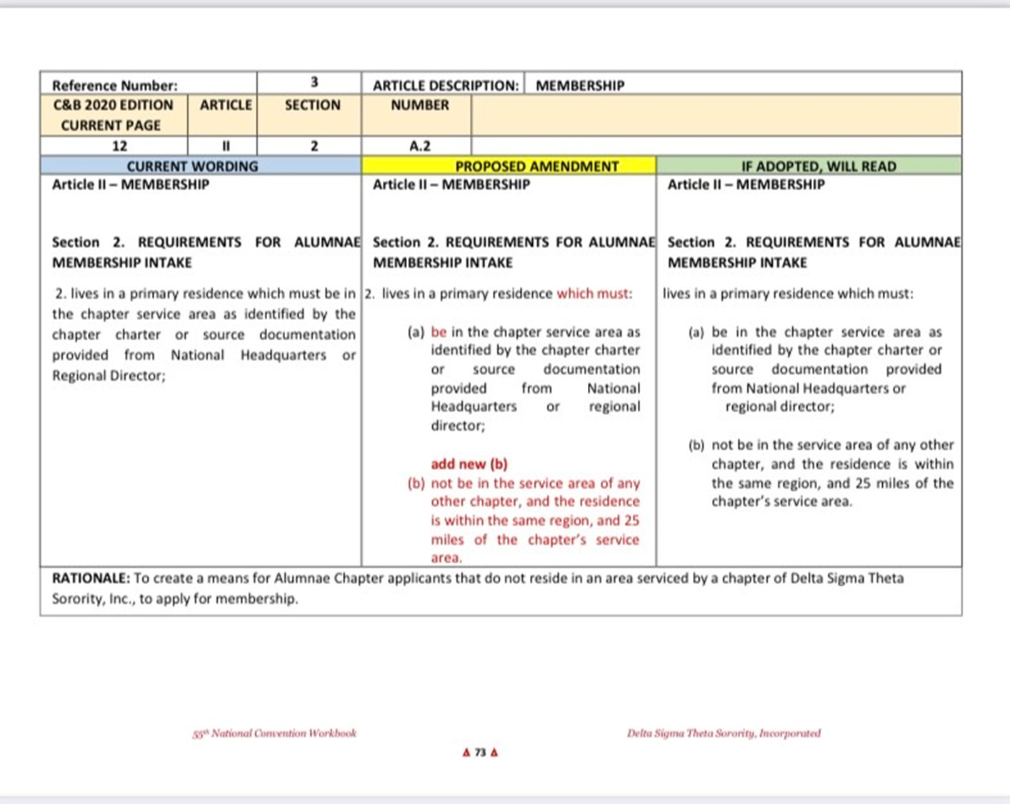

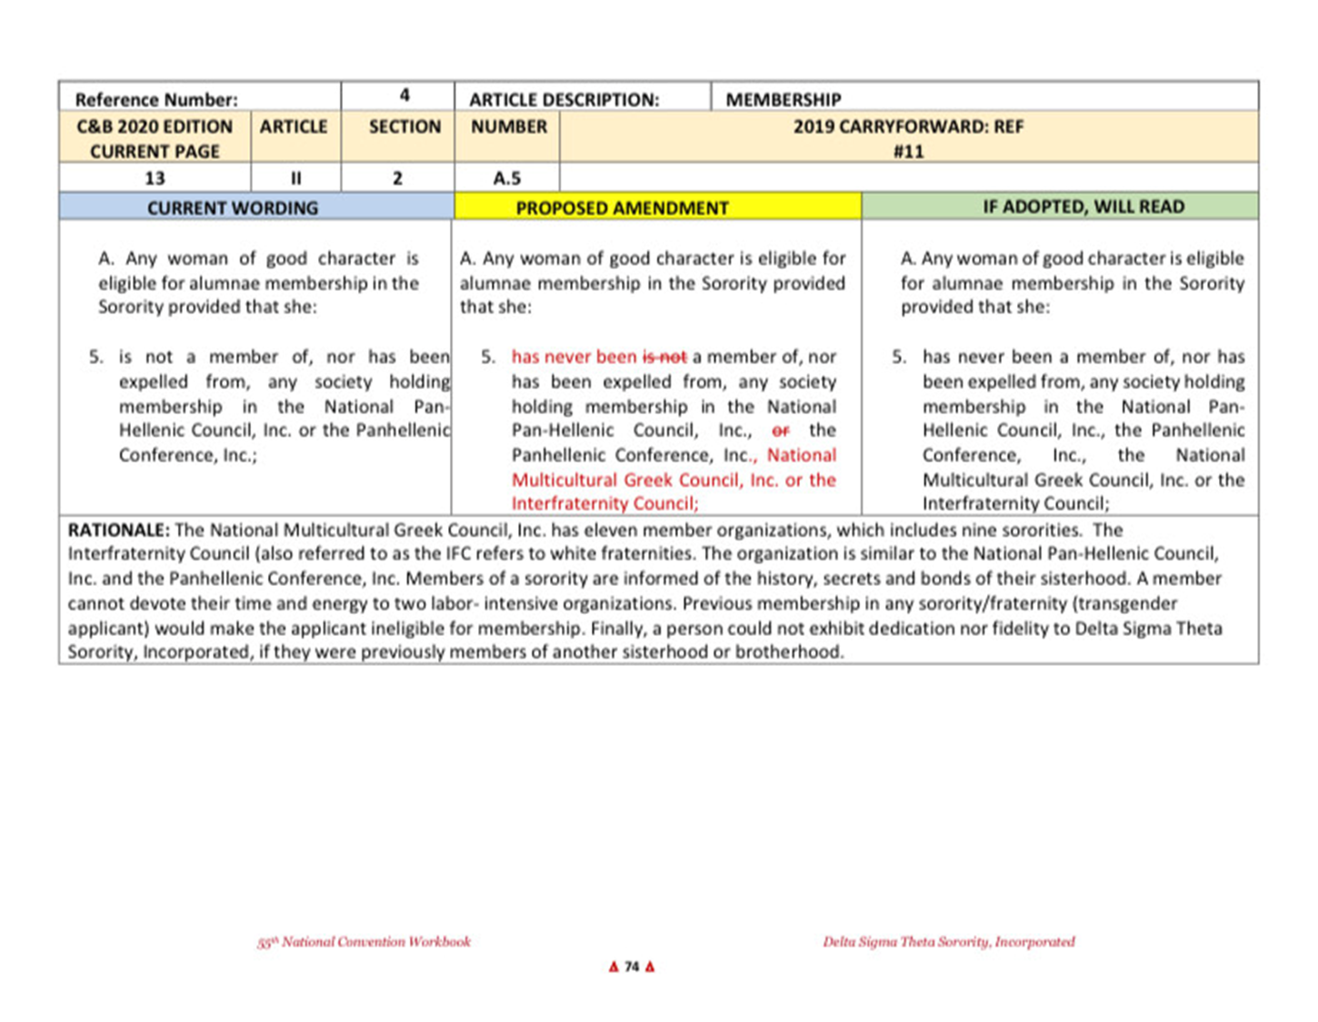

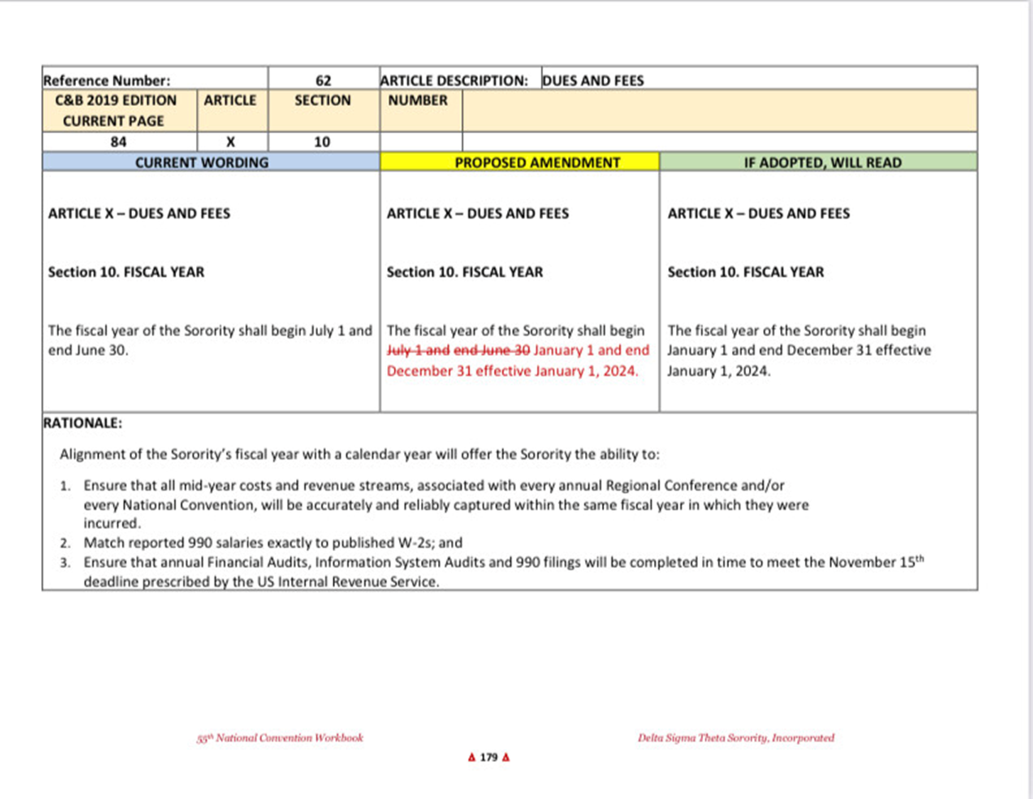

**SOCIAL ACTION: Soror Karen Braxton**

**PAST EVENTS**

* **Redistricting Town Hall: Analyzing and Evaluating the New District Maps (03/31)**
* **Delta Days in the United Nations (03/24 & 03/25)**
* **Delta Days in the Nation’s Capital - Mtgs. w/Legs.**
  + **Meeting with U.S. Senator Gary Peters (04/06/2022)**
  + **Meeting with U.S. Representative Tlaib (04/11/2022)**
* **The CROWN Act Passed!!!!!!!**
* **Justice Kentanji Brown Jackson was confirmed!**
  + **UPCOMING EVENTS**
* **04/16; Voter Registration Drive @ Smith Chapel; 1- 5 p.m.**
* **05/05; Expungement Forum (virtual); 6:30 p.m.**
* **05/30; Inkster Memorial Day Parade**
* **Delta Days in the State Capital**
* **Dates**
* **May 11 @ 9 a.m. (in-person)**
* **May 12 @ 5:30 p.m. (virtual)**
* **Registration**
* **Closes on Monday, April 11**
* **tinyurl.com/2022DDSC**
* **COVID-19 protocol (in-person)**
* **Vaccinated AND BOOSTED (if eligible)**
* **Masks are required**
* **PLEASE REGISTER!!!!!**

**NOMINATING: Soror Jenita Moore**

**Chair: Jenita Moore**

**Members: LaTanya Beanum**

**D’Angela Pitts**

**Note:**

There was a campaign violation by a candidate

The committee met and determined that the violation was made in error and there was no mal intent. Therefore the initial slate of candidates will go on as presented at EBoard.

**PAST EVENTS:**

* **Crimson and Cream Roundtable-Where the Money Resides!**

Date: Saturday, March 12, 2022

Time: 10-10:45am-During Sisterhood Hour

**UPCOMING EVENTS :N/A**

* **Nominating Committee Calendar**
* **March 24th Present Slate at E-Board**
* **April 9th Chapter meeting present slate / take nomination from the floor**
* **April 29th 10-day notification sent to chapter of the vote for open position (electronically and/or USPS)**
* **May 14th Candidate Forum (questions) & chapter vote for candidates**
* **June 11th Installations of officers**
* The Nominating Committee has the responsibility to select and recommend for consideration, qualified candidate for current eligible positions.
* **Inkster Alumnae Chapter 2022-2024 Eligible Positions**
* Corresponding Secretary, Recording Secretary, Financial Secretary, Asst Financial Secretary.
* The term of office for all officers shall be two (2) years.
* **Eligibility Criteria for holding Office**
* All candidates nominated for offices must be financial both locally and nationally for the fiscal year in which nominations occur. To serve in the position, her dues must be paid by the fiscal year in which she is to serve.
* **Eligibility Criteria for holding Office**
* All candidates shall:
* Be willing to participate/attend chapter activities,
* Have attended a Regional Conference/National Convention,
* Be committed to attend the specified workshops and trainings related to her office at the regional conference and national convention during her term.
* Candidates for the office of Corresponding Secretary shall have the ability to:
* Check all correspondence
* Review and classify all correspondence
* Report correspondence at Chapter and Executive Board Meetings
* Candidates for the office of Recording Secretary shall have the ability to:
* Take minutes accurately
* Send minutes in a timely fashion
* Post minutes in the secured area
* Candidates for the office of Financial Secretary and Assistant Financial Secretary shall have the ability to:
* Understand Finance and bookkeeping
* Keep accurate records of receipts and disbursements
* Possess computer skills and have internet access to process transactions and retrieve statements.
* **The 2022 Slate of Candidates are:**
* For the Office of Corresponding Secretary
* Toi Flynn
* For the Office of Recording Secretary
* Leslie Grace
* For the Office of Financial Secretary
* Joi Miller
* Monik Thomas
* For the Office of Assistant Financial Secretary
* Vacant
* April 9th Chapter meeting present slate / take nomination from the floor
* **Nominations from the Floor!!**
* The following positions are open for Nomination
* Soror President I am willing to take Nominations from the floor for the following:
* Corresponding Secretary
* 0 Nominations from the floor
* Recording Secretary
* 0 Nominations from the floor
* Assistant Financial Secretary
* Financial Secretary
* 0 Nominations from the floor
* 0 Nominations from the floor

**GROW WITH GOOGLE:** Soror Rhoda Pitts presented by Soror Faith Ivey

* **NO REPORT**

**UNFINISHED BUSINESS:**

* None

**NEW BUSINESS:**

* None

**ANNOUNCEMENTS**:

* **May Week Dates:**
* Sunday, May 15, 2022 – Sunday, May 22, 2022
* May Week Theme: “Elevating, Enhancing and Empowering the Women in Our Community”
* Sunday, May 15, 2022: Church Service at New Hope in Taylor (In-Person)
* Monday, May 16, 2022: “Delta Days at Inkster City Council Social Action (In-person.)
* Tuesday, May 17, 2022: 22 Minute Prayer Call with our Chaplain, Shai James-Boyd at 7:00 am and Splash of Red at Social 734
* Wednesday, May 18, 2022: Delta DEARS Tea at Social 734 (In Person) Membership Committee
* Thursday, May 19, 2022: “Melanin and Maternity” Panel Discussion at The Redford Library (In-Person) Physical and Mental Health
* Friday, May 20, 2022: International Service Project and Cultivation at Springhill Baptist Church (In-Person Outdoors) International Development Committee
* Saturday, May 21, 2022: Scholarship Recognition Virtual on Zoom Scholarship Committee
* Saturday, May 21, 2022: Support a Black Female Owned Business
* Economic Development
* Sunday, May 22, 2022: Virtual Sunday Service with El Bethel Church in Redford (In-Person)
* **Grow with Google**
* Create a Professional Resume with Google Docs
* April 30, 2022- 1:00pm-2:30pm
* State Coordinator Moore
* Please register for the Delta Days at the State Capital in-person and Virtually. There in an opportunity to flip the senate this year and we need as many sorors present as possible.

**ADJOURNMENT:**

**Motion to adjourn meeting, Soror Lisa Shorter, seconded by Soror Shareia Carter. Motion carried unanimously by consensus vote. Meeting adjourned 1:18 PM.**

Minutes respectfully submitted,

Soror Leslie V. Grace

*Received by Inkster Alumnae Chapter President, Vivian Kirkland_____________________________*